Data Analysis

All data were stored in a spreedsheet and then analysed according to a one-way factor design with Treatment factor as main experimental factor of interest.

For experiments testing the effect of Treatment (AsaiaWSP vs AsaiapHM4, Leishmania, LPS and Med) on cytokine expression and phagocitos we used Estimation Statistics (ES) approach ( Cumming, Geoff (2012). *Understanding The New Statistics: Effect Sizes, Confidence Intervals, and Meta-Analysis*. New York: Routledge.). Estimation statistics is a simple [framework](https://thenewstatistics.com/itns/) that—while avoiding the pitfalls of significance testing () —uses familiar statistical concepts: means, mean differences, and error bars. More importantly, it focuses on the effect size of one's experiment/intervention, as opposed to significance testing by calculatin effect size ( mean differences) with his 95% confidence interval , using the bias-corrected and accelerated (BCa) bootstrap confidence interval of [Efron and Tibshirani (1993](https://www.sciencedirect.com/science/article/pii/S2213224417300329" \l "bib12); suggested by [Rózsa et al., 2000](https://www.sciencedirect.com/science/article/pii/S2213224417300329" \l "bib45)) , (BRADLEY EFRON, Nonparametric estimates of standard error: The jackknife, the bootstrap and other methods, Biometrika, Volume 68, Issue 3, December 1981, Pages 589-599, <https://doi.org/10.1093/biomet/68.3.589>,L. Rózsa, J. Reiczigel, G. MajorosQuantifying parasites in samples of hosts

J. Parasitol., 86 (2000), pp. 228-232 ).

Bootstrap resampling gives us two important benefits:

1. Non-parametric statistical analysis. There is no need to assume that our observations, or the underlying populations, are normally distributed. Thanks to the Central Limit Theorem, the resampling distribution of the effect size will approach a normality.

2. Easy construction of the 95% CI from the resampling distribution. For 1000 bootstrap resamples of the mean difference, one can use the 25th value and the 975th value of the ranked differences as boundaries of the 95% confidence interval. (This captures the central 95% of the distribution.) Such an interval construction is known as a percentile interval.

The ES approach produce a plot which presents the rawdata (top panel) and the bootstrap confidence interval of the effect size (the difference in means) (bottom panel) aligned as a single integrated plot, called Cumming plot (fig.x)

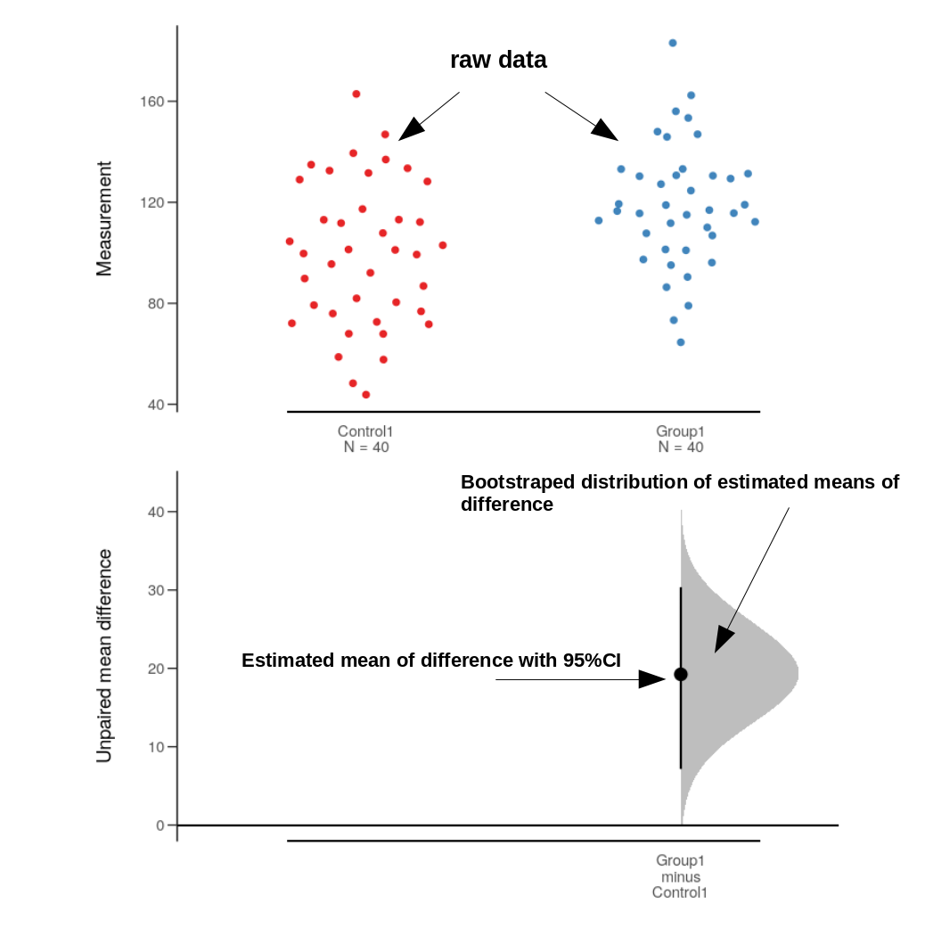

Anyway in order to have a measure of a continuous measure of evidence against the very Null Hypothesis ( mean difference = 0) we applied for each contrast a Fisher’s significant test ( bootstraped Welch two-sample t-test ) and exact p-values are reported.

Data analysis and graphics associated were performed in R language using dabestr (ref.) package for Estimation Statistics (bias-corrected and accelerated (BCa) bootstrap confidence interval and Cumming plot), and Mkinfer package

for bootstraped Welch two-sample t-test using boot.t.test() function.